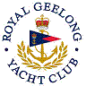 | Royal Geelong Yacht Club Inc.  Est 1859
Trophy Deed of Gift.

Trophy: | Series Winner of Navigation Rallies Perpetual Trophy
Presented by: | Terricalls Insurance and Financial Services
Date: | 2013
For: | Series Winner of Nav rallies
Remarks / Revisions
Click here for a List of Recipients

